The MYRC/HAAI PARTNERSHIP EVENT

The partnership between Manyatta Youth Resource Centre (MYRC) and Health Aid Assistance International (HAAI) first activity was done on 25th April 2025 at the Gonda grounds bringing its message of safe sanitation for girls during their menstrual period within their homes and at school. The main audience were girls of school going age and the special target was the girls in boarding school. The guest invited to this event included Dr.Parma a cardiologist in Agah Khan hospital, a member of Board of directors of HAAI, the county minister of Sports, culture gender and youth affairs, Make me Smile group of girls, Aspire Foundation, SHOFCO representative and many other visitors and community members. The host organizations were MYRC and Dr Zeinab, Program Coordinator from HAAI, Kisumu.

Stressing on the need of girls dignity during their menstrual circle when in school and also at home.The girls struggle to afford basic menstrual products, resorting to makeshift solutions like rags, old or even tissue paper, sometimes going for support from men who then turn to them form favor on . This silent crisis forces 42% of schoolgirls to miss school during their periods, robbing them of their education and potential.

On 25th April 2025, the event starting at around 10.00am official opened by Mr. Anthony Oballa from MYRC.

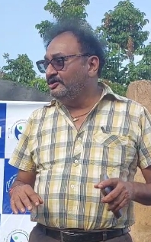
A message from a member of the Board of Directors from HAAI
Dr. Parma, a Cardiologist in Kisumu. A member of Board of HAAI

“Jambo, my name is Dr. Parma, from Kisumu. Am one of the members of Board of Directors for HAAI. We have a big number of directors there, and also coordinators, we have CEO. We are based in Nairobi, our head office in Nairobi,we do also work in Kakamega. Sahi we have now Kisumu Branch also, being handle by Dr. Zeinab. What we do, is to help the young girls. We are focusing more on health part of it. The first most is how to live well health wise. Anthony has now mentioned about the menstrual hygiene. So we are organizing how to help the young and young adult female group, so we will be assisting in giving the sanitory pads and other health assistance.

We also have a group in Kibera in Nairobi, and we assist in football match for the young girls. We have a team there. We have a match on 28th of this month. We have one branch Kakamega, and in kakamega we assist the middle age farmers we assist in farming so that they can grow their own income and help themselves. We began last year, we have been active since November 2024. So its quite a young organization, we are going to develop more and more.

Last month we launched our HAAI in Nairobi and we are now seeking assistance from different sponsors, who can sponsor us, both materially or financially so that we can assist the population in Kisumu, Kakamega and Nairobi. Soon we will be having a branch in Mombasa as well, but may be it will take some time. We have our CEO, she is called Joan, she’s is the one who is coordinating all those activities. As we speak, she is also one of the team member, we have other team members in the group. But we will be doing some bit of responsibility and work in Kisumu on behalf of them. So time to time we’ll be collaborating with Ephy, Anthony and other similar group so that we can uplift the young girls and young women in Kisumu. So in future we will be coming together. For now, I think we will be doing some donation of sanitary pads. Daktari will take over the donation program. Asanteni sana”.

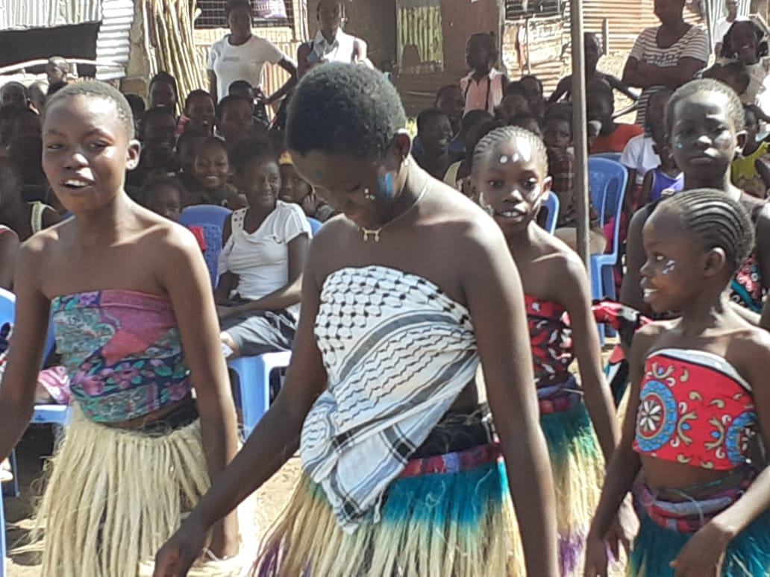
A presentation from Aspire Foundation girls started off the event.
Aspire Foundation performing their opening event

This was a traditional dance show casing the talents the young girls from Aspire Foundation, passing the information through the local language and showed their dancing skills to entertain the audience

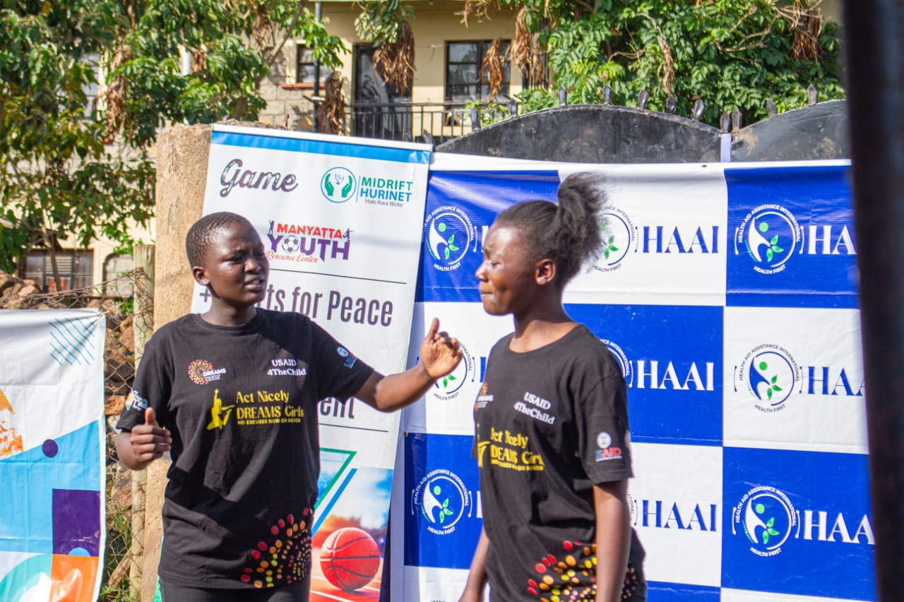
The Make me Smile (Act Nicely production)
Act Nicely a young girls group performing a skit

Act Nicely Production team, is a team of young girls between the ages of 14 - 23 years who purposely do skits to educate the community in various issues affecting the community and more so the girls

From this performance a message of
- No discrimination on girls because of mensuration.
- No stigma should be associated during this period
- Menstrual Circle is normal
- Maintaining hygiene (bathing twice a day when on the circle, change the pads often) to avoid bad smell and some diseases.
- Don’t be shy to ask for a pad when in need from the school teachers or the county administration.

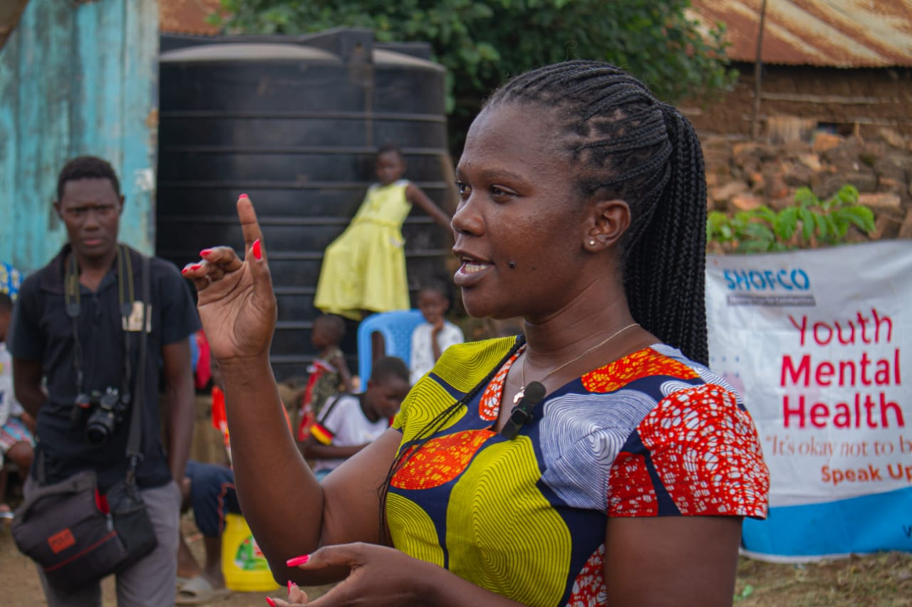
The County Minister of Sports, Culture, Gender and Youth Affairs, Madam Beatrice addressed the girls and this is what she said. “Periods is a good thing and don’t fear. Even us ladies we still under go the same. Let’s not be cheated by wrong me, pads can be provided by the county or an administrative office. Feel free to know any time of need for this product. And I promise the county will support MYRC with pads for girls around Manyatta Gonda”. This program will bring dignity to our girls and young women.
Madam Beatrice, The Kisumu, county Minister f Sports, Culture, Gender and Youth Affairs addressing the girls

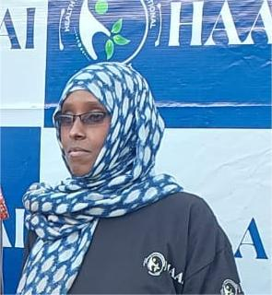
Dr. Zeinab, project coordinator HAAI, spearheaded the distribution of the sanitary pads

The Project Coordinator HAAI Dr.Zeinab, equally addressed the girls on matters to do with keeping good hygiene and she said, “We will provide the sanitary pads periodically to MYRC so that the girls will have the pads when in need. This is a good project and I hope we will help the community”. When going through this, ensure that you keep clean, change your pads often, so that you avoid some deseases that may be caused by poor menstrual hygiene. So HAAI is coming in to help provide these pads and also involve the girls and boys in other activities that will help them. Let join hands to support programs that bring dignity to our young girls. She apprectiated the attendance of the girls and also thanked them for coming for the activity.
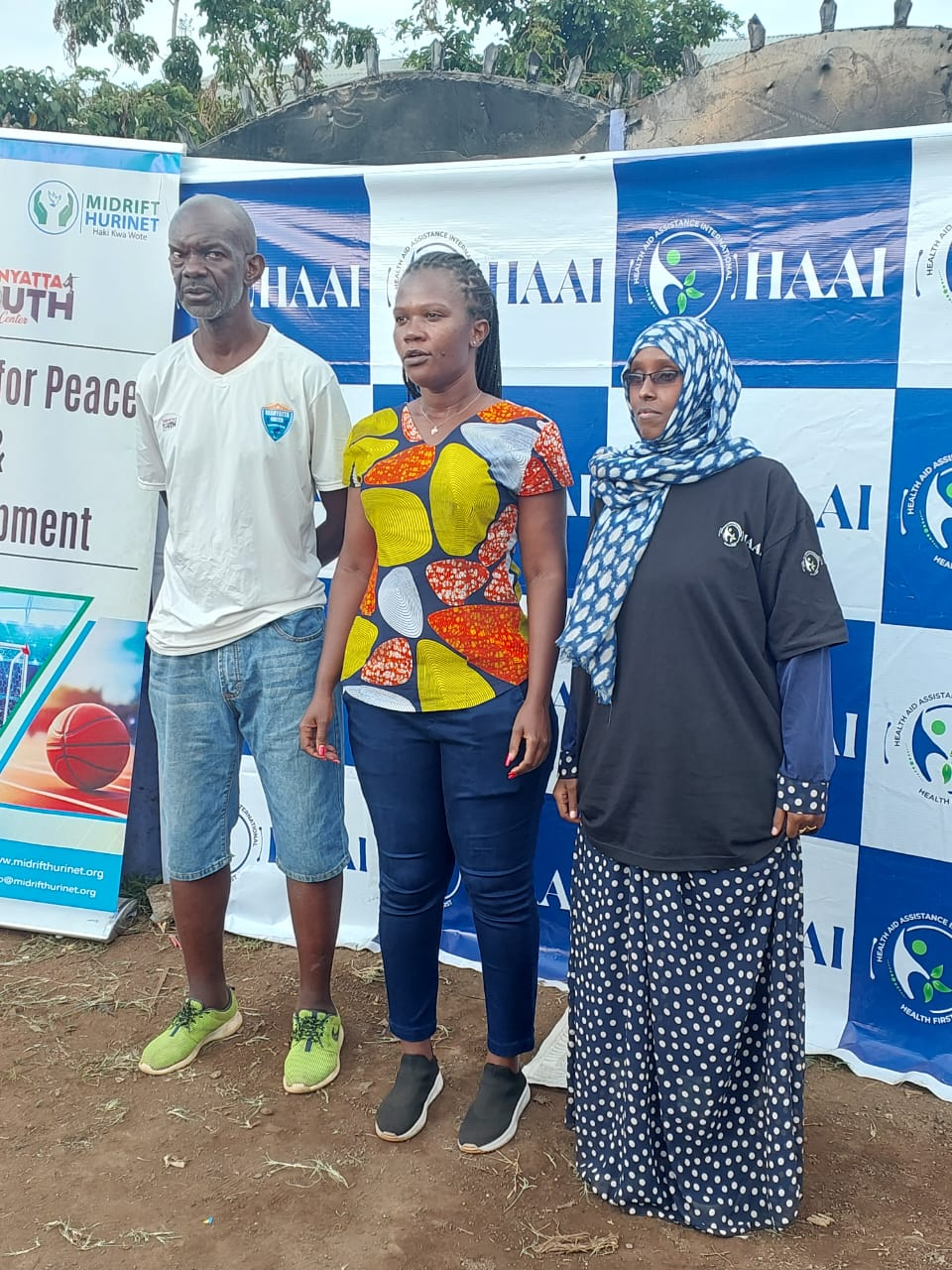
Mr Anthony Oballah Mzee, MYRC Director

We at Manyatta Youth Resource Centre (MYRC) would like to appreciate our new partners Health Aid Assistance International (HAAI) in this noble course as we create positive solutions towards providing positive change.

By providing solution to issues affecting our girls and young women within the community, we say thank you to HAAI for the collaboration. We would also like to appreciate our County Minister of Sports, Culture, Gender and Youth Affairs, Madam Beatrice. She is a role model to our young girls and we appreciate her presence during this activity. “Let us embrace this program.

Number of participants
Age | Male | Female | Total
>18Years | 9 | 267 | 276
<18Years | 12 | 13 | 25
Total | 21 | 280 | 301

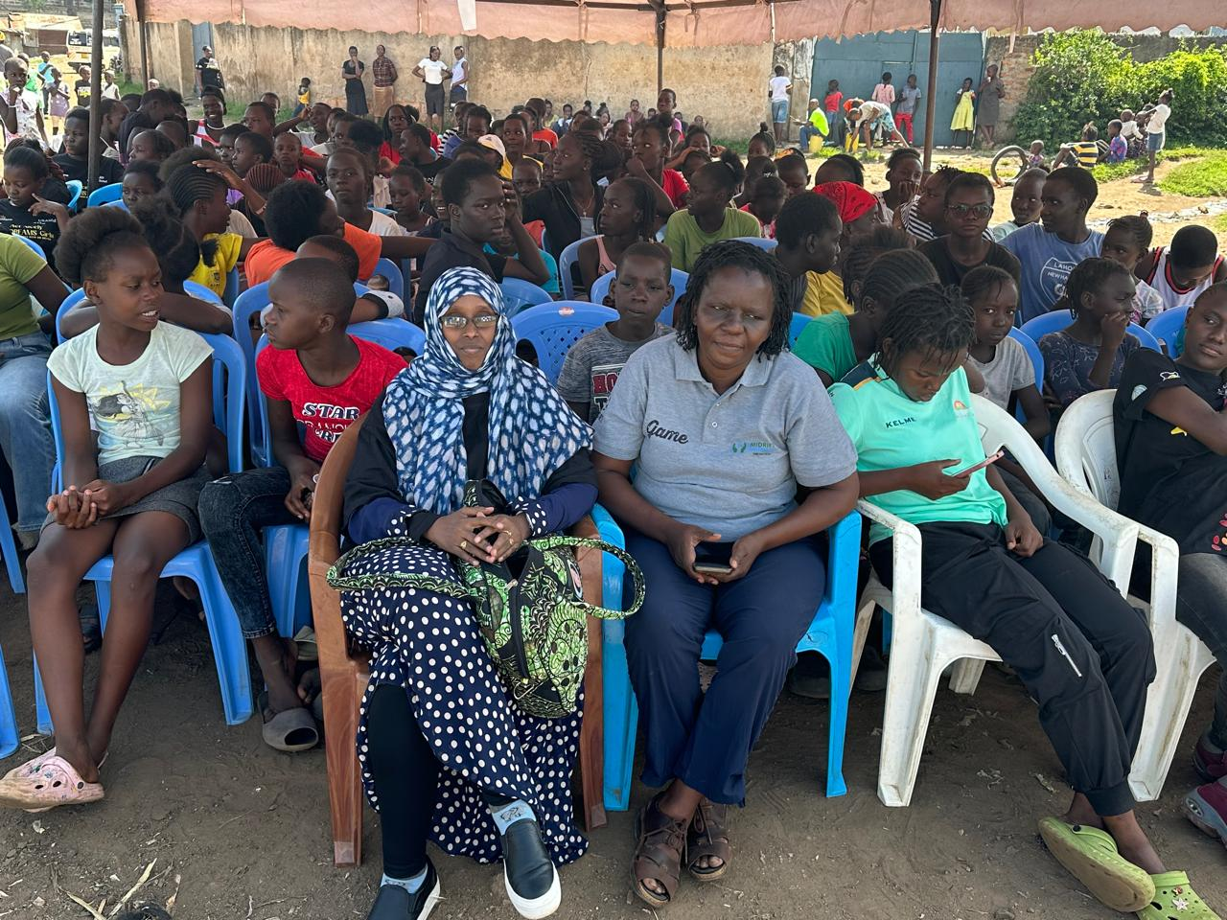
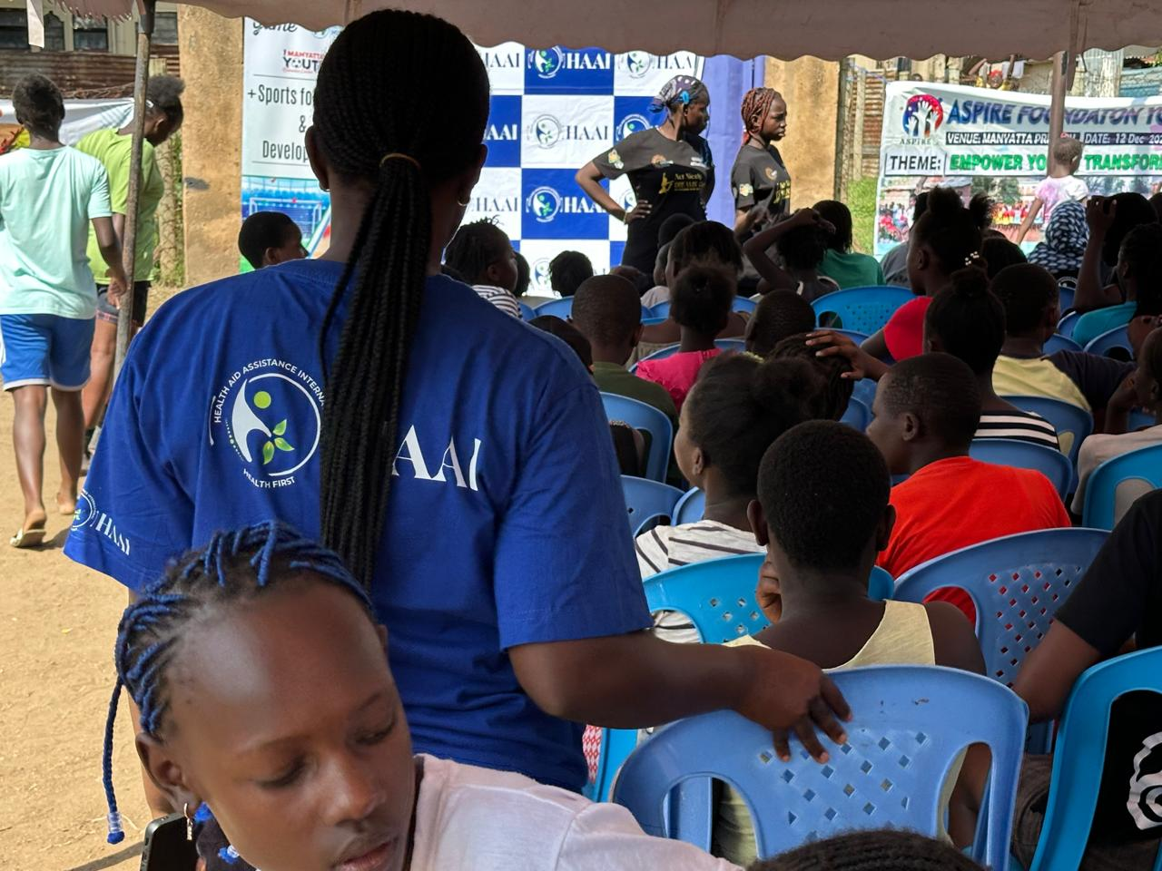
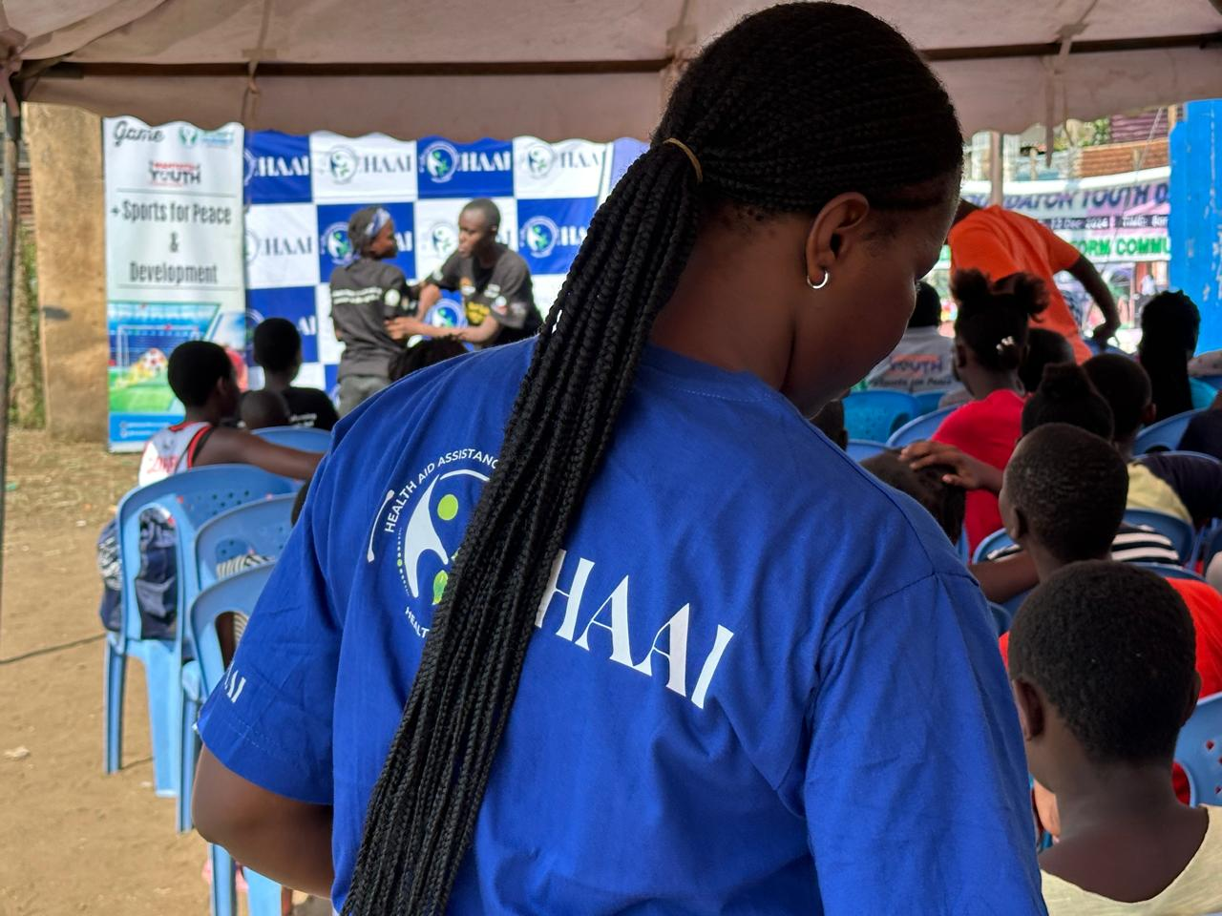
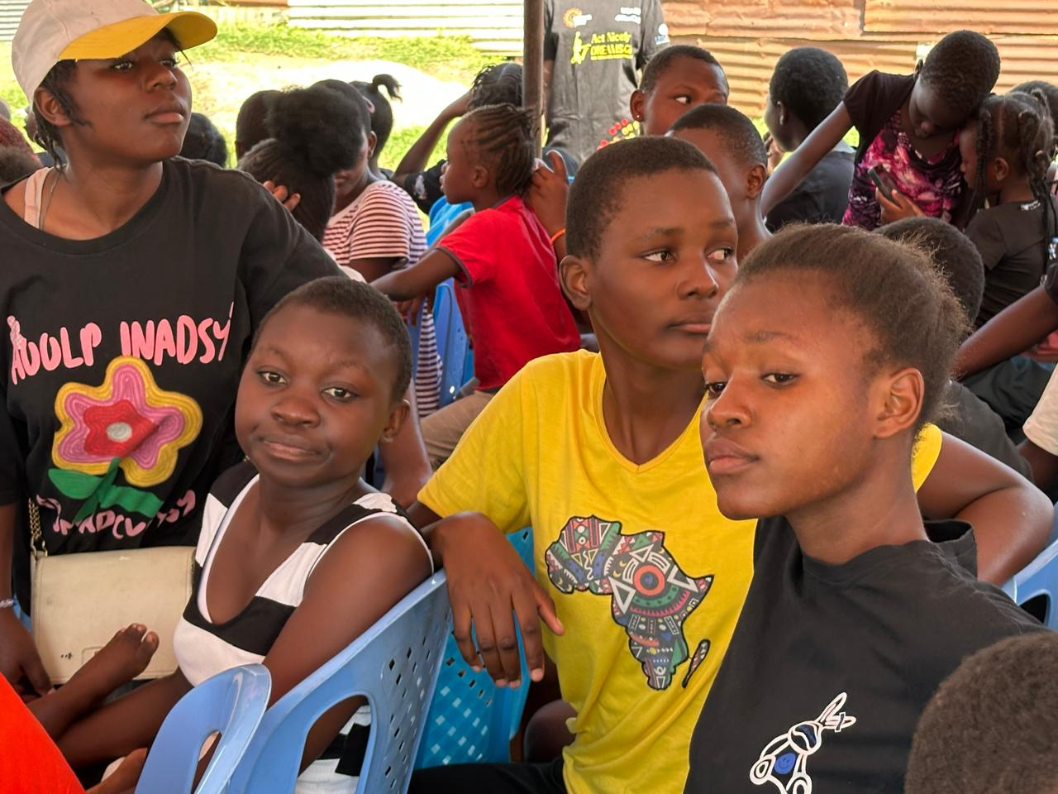
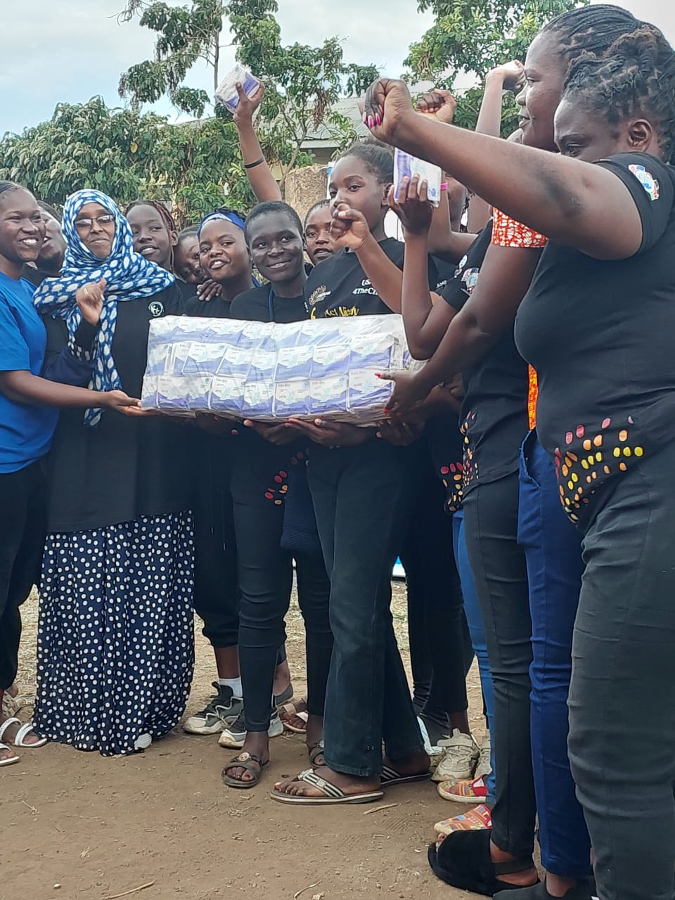
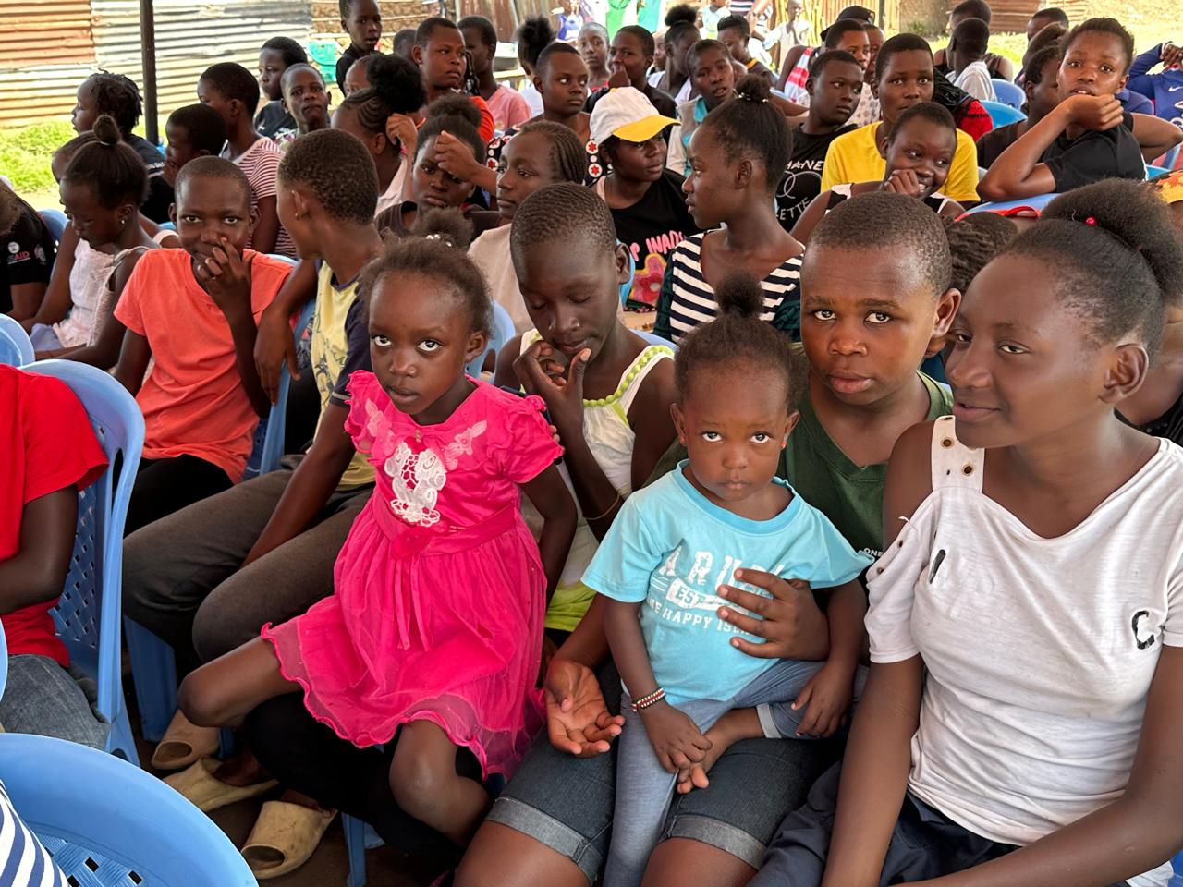
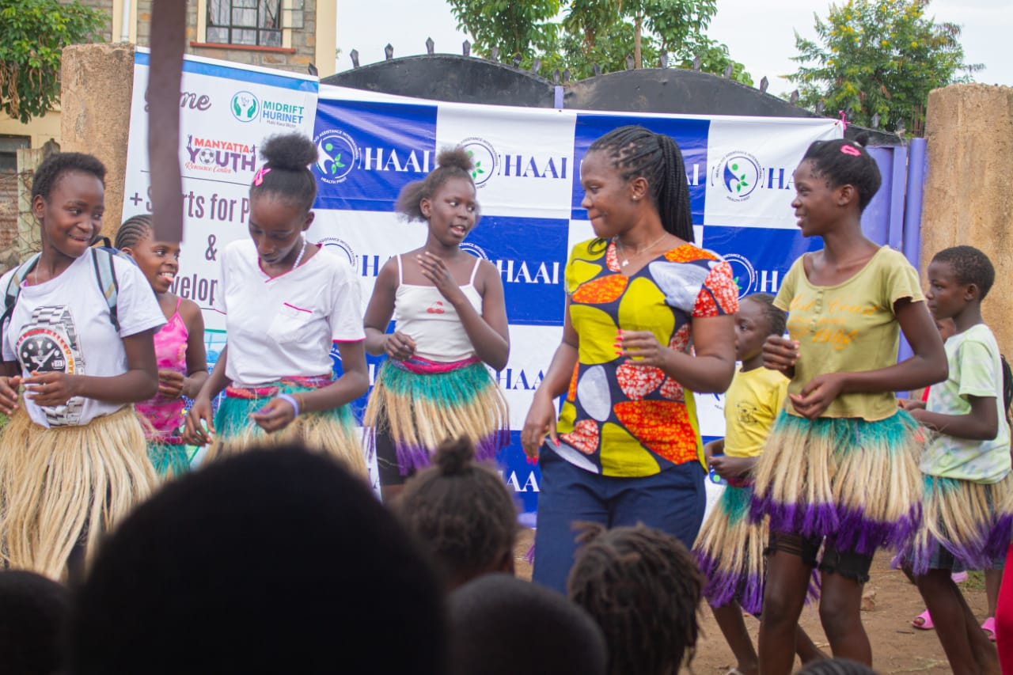
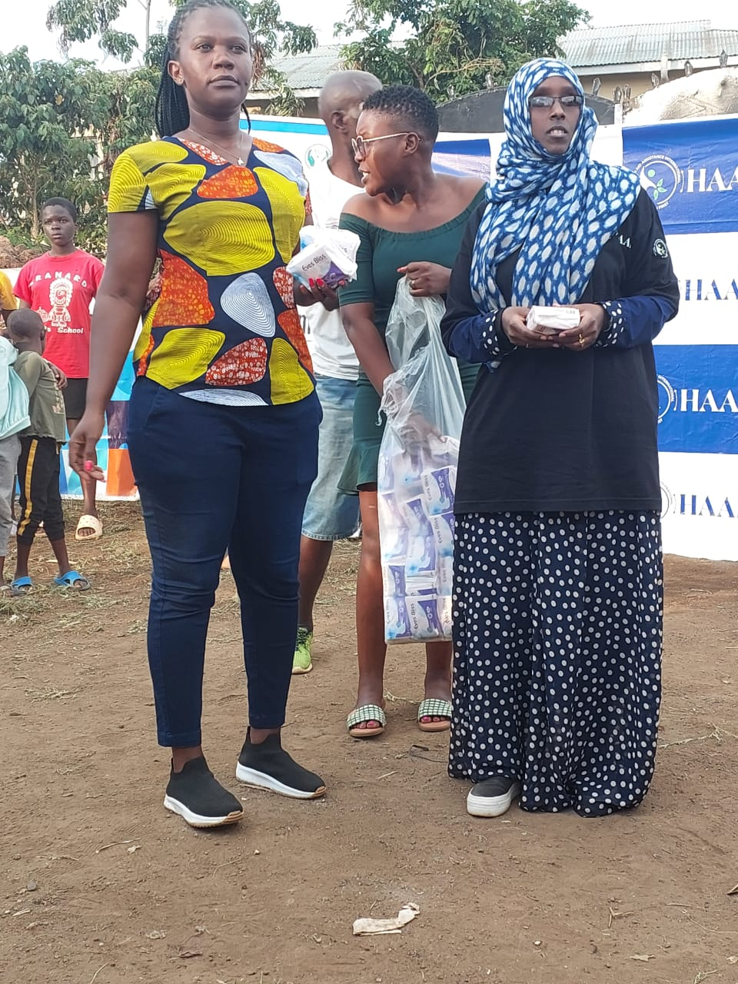
Some young and old boys/men joined the event in support of the girls. There is need to involve men in the issue of menstrual circle and provision of sanitary pads to the girls.
A group of ladies survivors against GBV”

